

Object-Oriented Programming Project

SPACE INVADERS
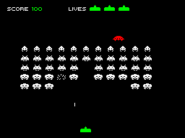
The project is a game called Space Invaders. Space Invaders is a 2D game which created in late seventies. It’s basically a spaceship shooting unfriendly things in space like aliens or meteors in some cases and earning points before they get close enough to kill you. It is one of the most popular and oldest in all the arcade games. You can see the how it originally looks like of an average game’s screen on the right side.
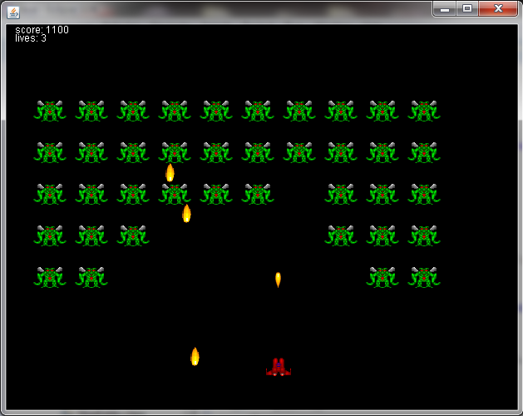
My design of the game is in a package file and it looks pretty much like the original one. There are some differences like the shooting, aliens and our ship’s images but the only reason for that is I couldn’t find the same images in the right format. Also my score and lives charts are more simple and I only have one type of alien. You can see the screenshot of my version of the game left side. You get 100 points for every alien you killed and you have three lives at the beginning. The aliens are also shooting at you they are getting close every time they hit the side of the screen. If you lose all your lives then it’s game over. The real weakness of our game is that I only did one level and it’s quite easy. And I should warn you about how hard for an ordinary computer to launch this game with normal speed because it’s pretty big for Java in Eclipse. My computers really suffered when I was finished, I recommend you to use a good computer for playing this game in Java.
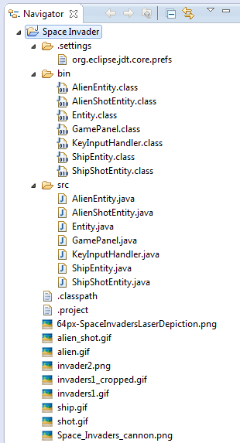
I created a GamePanel class, extends Jpanel, and used that as our center to use others. For example I have a short class named KeyInputHandler, extends KeyAdapter, to control the movements and shooting of our ship as an Action Listener. Even the game’s end screen, depending on whether you win (YOU WON) or lose (GAME OVER) of course, is written in GamePanel. But the real important class I used in the GamePanel is the Entity class. This class is not so long but it creates every shape in the game. AlienEntity class uses AlienShotEntity class, which is a short class for creating and arranging the movement of the shoots coming from aliens, after it created the aliens and arranged their movements. ShipEntity class uses ShipShotEntity class, which is a short class for creating and arranging the movement of the shoots going from our ship, after it created the ship and arranged it’s movements by using GamePanel. All of the four entity classes extends the Entity class so I can say it’s our most important class. You can see the Java Project I did in the Navigator and every part of my Space Invaders including the classes I made and the visuals I used in the right side.
To sum up, I created my own Space Invader game by using Java in seven classes including a panel, a keyboard adapter, four shapes and one creator of the shapes. I found the visuals from internet. I also searched online for the different versions and designs of this game and found very good examples but the complicated structures were hard for me to understand easily so they didn’t help much to me. In the end I succeeded and now we can play it whenever we want. I hope this would help you understand the code.



OZAN DENGİZ
B.Sc. Electrical & Electronics Engineer

